Project Title:
WEEK 1 ASSESSMENT REPORT
Data Cleaning and Preliminary Analysis Using R

India Air Quality Analysis (2020–2025): Data Cleaning and Preliminary Analysis Using R
Submitted by: Priyadarsine G.N.
Programme: M.Sc. Data Science
Task: Week 1 – Data Cleaning and Preliminary Analysis with R
Tool Used: R / RStudio
Dataset: India Air Quality Dataset, 2020–2025
Dataset Period: 1 January 2020 – 31 October 2025

Introduction
Air pollution is an important environmental and public health concern in India. Air Quality Index (AQI) provides a standardized way of representing air pollution levels and helps in understanding the overall quality of air in different locations.
For this Week 1 assessment, an India Air Quality dataset covering the period from January 2020 to October 2025 was selected. The dataset contains daily air-quality observations across Indian cities along with AQI values and air-quality categories.
The main objective of this project is to perform data cleaning, preprocessing, descriptive statistical analysis, and preliminary exploratory data analysis (EDA) using R. The analysis focuses on understanding the structure and quality of the dataset, identifying missing and duplicate records, validating AQI values, detecting statistical outliers, transforming variables, normalizing numerical data, encoding categorical variables, and generating initial insights through statistics and visualizations.
The project was performed using RStudio, with base R functions used for data import, inspection, cleaning, transformation, statistical analysis, and visualization.

Dataset Overview

The selected dataset is a publicly available India Air Quality dataset covering
2020 to October 2025. The dataset contains:
- 378,328 observations
- 6 original variables
- 304 unique cities
- 2,130 unique dates
- 6 air-quality categories
- AQI values ranging from 3 to 500
The dataset provides a useful combination of numerical and categorical information, making it suitable for data-cleaning and preliminary analysis.

Dataset Variables

Variable Description Original R Data Type
Date Date of observation Character

S.No Month name, despite the misleading column name
City Indian city where the observation was recorded
Character

Character

Air.Quality Air-quality classification Character
AQI.Value Numerical AQI value Integer Prominent.Pollutant Prominent pollutant information Character Dataset Period
The date range was verified using R:
Start date: 01 January 2020
End date: 31 October 2025
Therefore, the dataset covers more than five years of observations, although

2025 is incomplete because the dataset ends on 31 October 2025
- Software and Tools Used
The analysis was performed using:

R
- RStudio
- Base R functions
- CSV data format
- R plotting functions
The R version used during the analysis was:

R version 4.6.1

- Dataset Import
The dataset was imported into R using the read.csv() function.

R Code
rm(list = ls())

aqi <- read.csv( "AQI_2020_to_2025_October.csv", stringsAsFactors = FALSE
)
The stringsAsFactors = FALSE argument was used so that categorical variables were initially imported as character variables and could be examined before being converted into factors.

Initial Verification
The following functions were used: head(aqi)

dim(aqi)

names(aqi)

Output
The dataset contained:

378328 rows
6 columns
The original column names were:
Date S.No
City Air.Quality AQI.Value
Prominent.Pollutant

Initial Dataset Inspection
After importing the dataset, the str() and summary() functions were used to understand the structure and statistical characteristics of the raw data.
R Code str(aqi) summary(aqi)

Structure of the Dataset
The str() output showed:
378328 observations of 6 variables
The variables were initially stored as follows:
    - Date → Character
    - S.No → Character
    - City → Character
    - Air.Quality → Character
    - AQI.Value → Integer
    - Prominent.Pollutant → Character
The Date variable being stored as character was identified as a transformation requirement.

Important Data Quality Finding
The S.No variable was found to contain month names such as:
    - January
    - February
    - March
    - ...
    - December
Therefore, despite its name, S.No was not a serial number.

Missing Value Analysis
A systematic missing-value check was performed for all variables.

R Code
colSums(is.na(aqi))
To calculate the percentage of missing values: round(
colSums(is.na(aqi)) / nrow(aqi) * 100, 2
)

Result
All six variables contained:

0 missing values

Variable | Missing Values | Missing %
Date | 0 | 0%
S.No | 0 | 0%
City | 0 | 0%
Air.Quality | 0 | 0%

AQI.Value | 0 | 0%
Prominent.Pollutant | 0 | 0%

Interpretation
Since no missing values were identified, no imputation or missing-value replacement was performed.
This is an important data-cleaning decision because missing values should not be artificially introduced or modified when they are not present in the original data.

Duplicate Record Analysis
Duplicate rows were checked using the duplicated() function.

R Code
sum(duplicated(aqi))

Result
[1] 0

Therefore, no completely duplicated records were found. Interpretation
Since there were no duplicate records, no rows were removed during duplicate handling.

Categorical Variable Validation
The categorical variables were examined to identify unexpected or inconsistent categories.
  - Air Quality Categories R Code unique(aqi$Air.Quality)

table(aqi$Air.Quality)
Six categories were identified:

Air Quality | Number of Records

Good | 74,986
Moderate | 114,209
Poor | 33,894
Satisfactory | 143,820
Severe | 1,176
Very Poor | 10,243
No unexpected category labels were found.

Prominent Pollutant Assessment
The Prominent.Pollutant variable was also examined.

R Code
unique(aqi$Prominent.Pollutant)
The result showed only one unique value:
"PM 2.5, PM 10 "
Therefore, this variable had only one unique category across the dataset. Interpretation
Because there is no variation in this variable, it does not provide useful information for comparative exploratory analysis. Therefore, it was not used as an analytical grouping variable in the preliminary EDA.
The variable was retained in the working dataset rather than being altered without justification.

AQI Range Validation
The range of AQI values was checked.
R Code range(aqi$AQI.Value) Result
3 500
The dataset contains AQI values from 3 to 500. Additional validity checks were performed.

Negative AQI values sum(aqi$AQI.Value < 0) Result:
0
AQI values greater than 500 sum(aqi$AQI.Value > 500) Result:
0
Missing AQI values sum(is.na(aqi$AQI.Value)) Result:
0

Conclusion
No negative AQI values, values above 500, or missing AQI values were found.

Date Transformation
The original Date variable was stored as a character variable.

Original Format
01-01-2020
31-10-2025
The date variable was converted into a proper R Date object.

R Code
aqi$Date <- as.Date( aqi$Date,
format = "%d-%m-%Y"
)
The conversion was verified using: class(aqi$Date)

head(aqi$Date)

range(aqi$Date)

Results
[1] "Date" Date range:
2020-01-01
2025-10-31

Interpretation
Converting the date variable into the correct Date format allows reliable temporal analysis and extraction of month and year information.

Validation of the Mislabelled S.No Variable
The S.No variable appeared to contain month names rather than serial numbers.
To verify this, the values were compared against the month extracted from the Date variable.
R Code table( aqi$S.No,
format(aqi$Date, "%B")
)
The result showed a perfect correspondence between the S.No values and the actual month of the observation.
A new Month variable was then created: aqi$Month <- format(
aqi$Date, "%B"
)
The consistency was checked using: sum(aqi$S.No != aqi$Month)

Result
[1] 0
This confirmed zero mismatches.

Removing the Redundant Column
After validating the Month information, the original S.No column was removed because it was redundant and misleading.

R Code
aqi$S.No <- NULL
The resulting variables were:
Date City
Air.Quality AQI.Value Prominent.Pollutant Month
The dataset still contained:

378,328 observations
No observations were lost during this transformation.

Outlier Detection
Outlier detection was performed using the Interquartile Range (IQR) method. The first quartile and third quartile were calculated.

R Code
Q1 <- quantile( aqi$AQI.Value, 0.25,
na.rm = TRUE
)

Q3 <- quantile( aqi$AQI.Value, 0.75,
na.rm = TRUE
)

Results
Q1 = 56
Q3 = 140
The IQR was:
IQR_AQI <- Q3 - Q1

IQR_AQI
Result:
84
The lower and upper bounds were calculated using:
lower_bound <- Q1 - 1.5 * IQR_AQI

upper_bound <- Q3 + 1.5 * IQR_AQI

Results

Measure | Value
Q1 | 56
Q3 | 140
IQR | 84
Lower Bound | -70
Upper Bound | 266
Therefore, AQI values above 266 were statistically identified as potential upper-side outliers.

Number of Outliers

outliers <- aqi[
aqi$AQI.Value < lower_bound | aqi$AQI.Value > upper_bound,
]

nrow(outliers) Result:

19,567 observations
Percentage:
round(
nrow(outliers) / nrow(aqi) * 100, 2
)
Result:
5.17%

- Outlier Investigation and Treatment Decision The detected outliers were not automatically removed. The highest AQI observations were investigated using: summary(outliers$AQI.Value)
and:
head( outliers[
order(-outliers$AQI.Value),
c("Date", "City", "Air.Quality", "AQI.Value")
], 10
)

The investigation showed observations with AQI values reaching 500 and classified as Severe.
Examples included observations from:
- Kalaburgi
- Rupnagar
- Udupi
- Gadag
- Ujjain
- Vijayawada
- Imphal
- Greater Noida
- Delhi

Treatment Decision
The detected outliers were retained. Reason
An IQR outlier is not automatically an incorrect observation. In an air-quality dataset, very high AQI values can represent genuine periods of severe pollution.
Therefore:
The IQR method identified 19,567 observations (5.17%) above the statistical upper boundary of 266. These observations were investigated and found to include legitimate severe AQI observations, including values reaching 500.
Therefore, the observations were retained rather than removed.
This approach avoids deleting potentially meaningful environmental observations.

Data Normalization
Normalization was performed on the numerical AQI.Value variable using Z-score standardization.
The formula used was: where:

• = original AQI value
• = mean AQI
• = standard deviation

R Code
aqi$AQI.ZScore <- as.numeric( scale(aqi$AQI.Value)
)
The result was verified using: mean(aqi$AQI.ZScore)

sd(aqi$AQI.ZScore)

Results
Mean:
2.429652e-17
This is effectively 0. Standard deviation:
1

Interpretation
The results confirm successful Z-score normalization.
The original AQI.Value was retained so that the actual AQI scale remains available for interpretation.

Categorical Encoding
The categorical variables were converted from character variables to factors.

R Code
aqi$City <- as.factor(aqi$City) aqi$Air.Quality <- as.factor(aqi$Air.Quality)

aqi$Month <- factor( aqi$Month,
levels = month.name
)
The structure was checked using: str(
aqi[
,
c("City", "Air.Quality", "Month")
]
)

Results
- City → 304 levels
- Air Quality → 6 levels
- Month → 12 levels
This allows R to treat these variables as categorical variables for grouping and analysis.

One-Hot Encoding
One-hot encoding was demonstrated using the Air.Quality variable.

R Code
air_quality_encoded <- model.matrix(
~ Air.Quality - 1, data = aqi
)
The resulting encoded dataset contained:
378,328 rows × 6 columns
The six binary variables represented:
- Good

- Moderate
- Poor
- Satisfactory
- Severe
- Very Poor
Each category was represented using binary 0/1 values.

Interpretation
One-hot encoding transforms categorical classes into numerical indicator variables, which can be useful for statistical or machine-learning algorithms that require numerical input.

Descriptive Statistical Analysis
The following descriptive statistics were calculated for AQI.Value.

R Code
aqi_stats <- c(
Mean = mean(aqi$AQI.Value), Median = median(aqi$AQI.Value), SD = sd(aqi$AQI.Value), Minimum = min(aqi$AQI.Value), Maximum = max(aqi$AQI.Value)
)

aqi_stats

Results

Statistic | Value
Mean | 109.55

Median | 88.00
Standard Deviation | 74.01
Minimum | 3.00
Maximum | 500.00
Quartiles were: quantile( aqi$AQI.Value,
probs = c(0.25, 0.50, 0.75)
)

Quartile AQI
Q1 56
Median 88
Q3 140
Interpretation
The mean AQI of 109.55 is higher than the median AQI of 88, indicating that the distribution is positively skewed. This observation is also supported by the AQI histogram presented in the EDA section.

Air Quality Category Statistics
The frequency of each air-quality category was calculated.

R Code
air_quality_count <- table( aqi$Air.Quality
)

air_quality_percent <- round( prop.table(air_quality_count) * 100,
2
)

Results

Air Quality | Records | Percentage
Satisfactory | 143,820 | 38.01%
Moderate | 114,209 | 30.19%
Good | 74,986 | 19.82%
Poor | 33,894 | 8.96%
Very Poor | 10,243 | 2.71%
Severe | 1,176 | 0.31%
Initial Observation
The Satisfactory category is the most frequent category, representing 38.01%
of all observations.
Satisfactory and Moderate observations together account for approximately:
68.20%
of the dataset.

Exploratory Data Analysis
Three simple visualizations were selected for the preliminary EDA. The purpose was to understand:
- The distribution of AQI values.
- The distribution of air-quality categories.
- The variation in average AQI across years.

AQI Distribution Histogram

R Code
hist( aqi$AQI.Value, breaks = 50,
main = "Distribution of AQI Values", xlab = "AQI Value",
ylab = "Frequency"
)

Figure

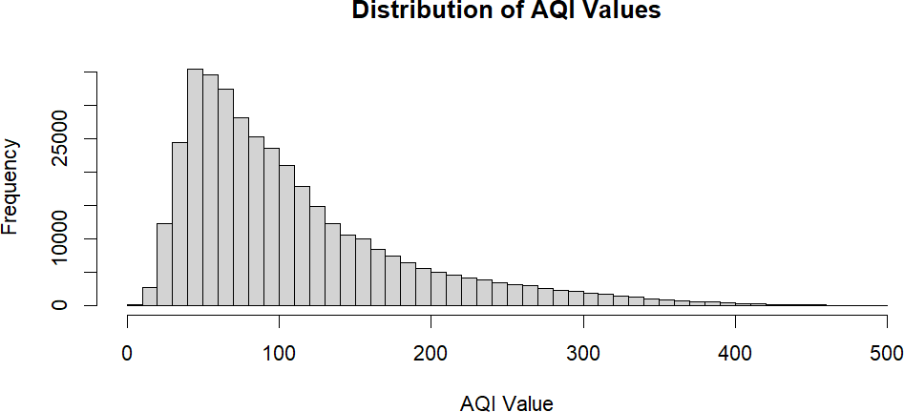

Interpretation
The histogram shows that most observations are concentrated at relatively lower AQI values, particularly around the range of approximately 40–150.
The distribution has a noticeable right tail extending toward 500, indicating the presence of relatively high AQI observations.
This is consistent with the descriptive statistics because the mean AQI (109.55) is greater than the median (88).

Air Quality Category Distribution R Code
barplot(

air_quality_count,
main = "Distribution of Air Quality Categories", xlab = "Air Quality Category",
ylab = "Number of Observations", las = 2
)
A horizontal version can be used for better readability: barplot(
air_quality_count,
main = "Distribution of Air Quality Categories", xlab = "Number of Observations",
ylab = "Air Quality Category", horiz = TRUE,
las = 1
)

Figure
Distribution of Air Quality Categories

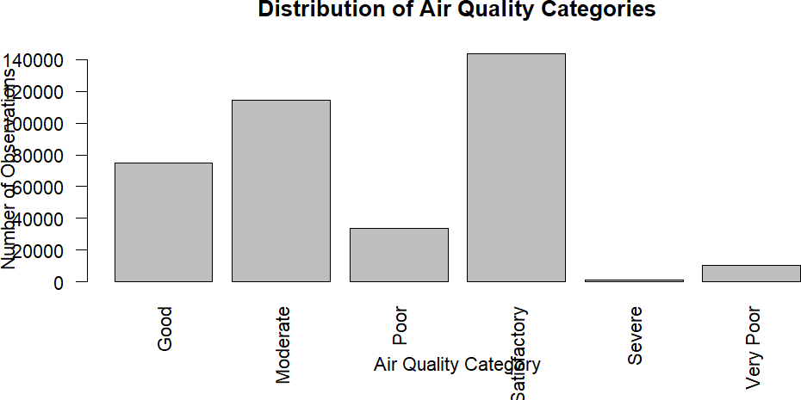

Interpretation

The Satisfactory category has the highest number of observations, followed by Moderate and Good.
The Severe category represents only 0.31% of the total observations. However, severe observations can contain very high AQI values, including values reaching 500.

Year-wise Average AQI
For a simple temporal analysis, the year was extracted from the cleaned Date variable.

R Code
aqi$Year <- format( aqi$Date,
"%Y"
)
Average AQI was calculated for each year: yearly_aqi <- aggregate(
AQI.Value ~ Year, data = aqi,
FUN = mean
)

yearly_aqi

Results

Year | Average AQI
2020 | 113.75
2021 | 120.77
2022 | 121.92
2023 | 115.09
2024 | 105.69
2025* | 87.66
*2025 contains observations only through 31 October 2025.

Visualization plot( yearly_aqi$Year,
yearly_aqi$AQI.Value, type = "o",
main = "Average AQI by Year", xlab = "Year",
ylab = "Average AQI"
)

Figure
Average AQI by Year

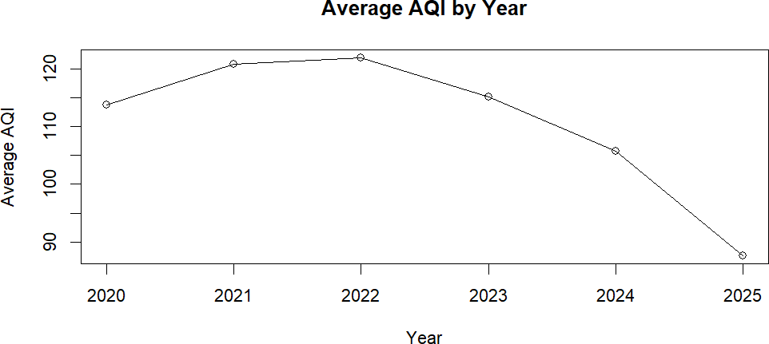

Interpretation
The average AQI increased from 113.75 in 2020 to a peak of 121.92 in 2022. After 2022, the average AQI declined:
- 2023 → 115.09
- 2024 → 105.69
- 2025 → 87.66
However, the 2025 value should be interpreted carefully because the dataset ends on 31 October 2025 and therefore does not represent a complete calendar year.

Initial Insights
Based on the data-cleaning and preliminary EDA process, the following initial observations were identified.

Insight 1 — AQI distribution is right-skewed
The mean AQI was 109.55, while the median was 88. The histogram also showed a long right tail toward higher AQI values.

Insight 2 — Satisfactory is the most common category
The Satisfactory category contains 143,820 observations, representing 38.01%
of the dataset.

Insight 3 — Moderate is the second-largest category
Moderate observations account for 30.19% of the dataset.

Insight 4 — Satisfactory and Moderate dominate the dataset
Together, Satisfactory and Moderate categories represent approximately
68.20% of all observations.
Insight 5 — Severe observations are relatively uncommon Only 1,176 observations, or 0.31%, were classified as Severe. Insight 6 — High AQI observations require careful treatment
The IQR method identified 19,567 observations (5.17%) above the statistical upper boundary of 266. These were retained because investigation showed that the observations included genuine Severe AQI values, including values reaching 500.

Insight 7 — AQI peaked in 2022
The highest annual average AQI in the available complete-year periods was

121.92 in 2022.
Insight 8 — 2025 should be interpreted carefully
The average AQI for 2025 was 87.66, but the dataset ends on 31 October 2025. Therefore, this value should not be treated as a complete-year comparison with 2020–2024.

Data Cleaning Summary
The complete data-cleaning process can be summarized as follows:

Cleaning/Preprocessing Task | Action | Result
Missing values | Checked using is.na() | 0 missing values
Duplicate records | Checked using duplicated() | 0 duplicates
Date format | Character → Date | Successfully converted
S.No validation | Compared with Date-derived month | 0 mismatches
Redundant column | Removed S.No | Successfully removed
Month variable | Derived from Date | Created
AQI validation | Checked negative/>500 values | 0 invalid values
Outlier detection | IQR method | 19,567 flagged
Outlier treatment | Investigated and retained | No valid observations removed
Normalization | Z-score | Mean ≈ 0, SD = 1
Categorical conversion | Factors | Successfully converted
One-hot encoding | Air.Quality | 6 binary variables

Limitations
The following limitations were identified during the analysis:
- The dataset did not contain missing values, so no imputation method was required.
- The Prominent.Pollutant variable contained only one unique value and therefore had limited analytical usefulness.
- The S.No column was incorrectly labelled because it contained month names rather than serial numbers.
- The dataset ends on 31 October 2025, so 2025 is not a complete calendar year.
- Correlation analysis was limited because only one primary continuous numerical variable was available.
- IQR outliers were retained because extreme AQI values may represent genuine environmental conditions rather than data errors.

Conclusion
This Week 1 project demonstrated a complete data-cleaning and preliminary exploratory-analysis workflow using R on an India Air Quality dataset covering January 2020 to October 2025.
The analysis began with dataset inspection using head(), dim(), names(), str(), and summary(). Data-quality checks confirmed that there were no missing values or duplicate records. The Date variable was converted from character format into a proper Date object. The misleading S.No variable was investigated, validated against the date information, and replaced with a meaningful Month variable.
AQI values were validated against the expected 0–500 range. IQR-based outlier analysis identified 19,567 statistical outliers, representing 5.17% of the observations. These observations were retained after investigation because they included potentially genuine severe pollution events.
The AQI variable was standardized using Z-score normalization, and categorical variables were converted into factors. One-hot encoding was also demonstrated for the Air Quality variable.
The preliminary EDA showed that the AQI distribution is positively skewed, with most observations concentrated at lower AQI values and a long right tail. Satisfactory was the most frequent air-quality category, while Severe represented only a small proportion of observations. Year-wise analysis showed

that average AQI peaked in 2022 and subsequently declined, although the incomplete 2025 period requires cautious interpretation.
Overall, the project demonstrates the practical use of R for data inspection,
cleaning, transformation, statistical analysis, and exploratory visualization, fulfilling the requirements of the Week 1 assessment.

